SUBCOURSE EDITION
IT0672 A

US ARMY INTELLIGENCE CENTER AND SCHOOL
ANALYZE INDUSTRIES IN GENERAL
AND EXTRACTION INDUSTRIES
ON AERIAL IMAGERY

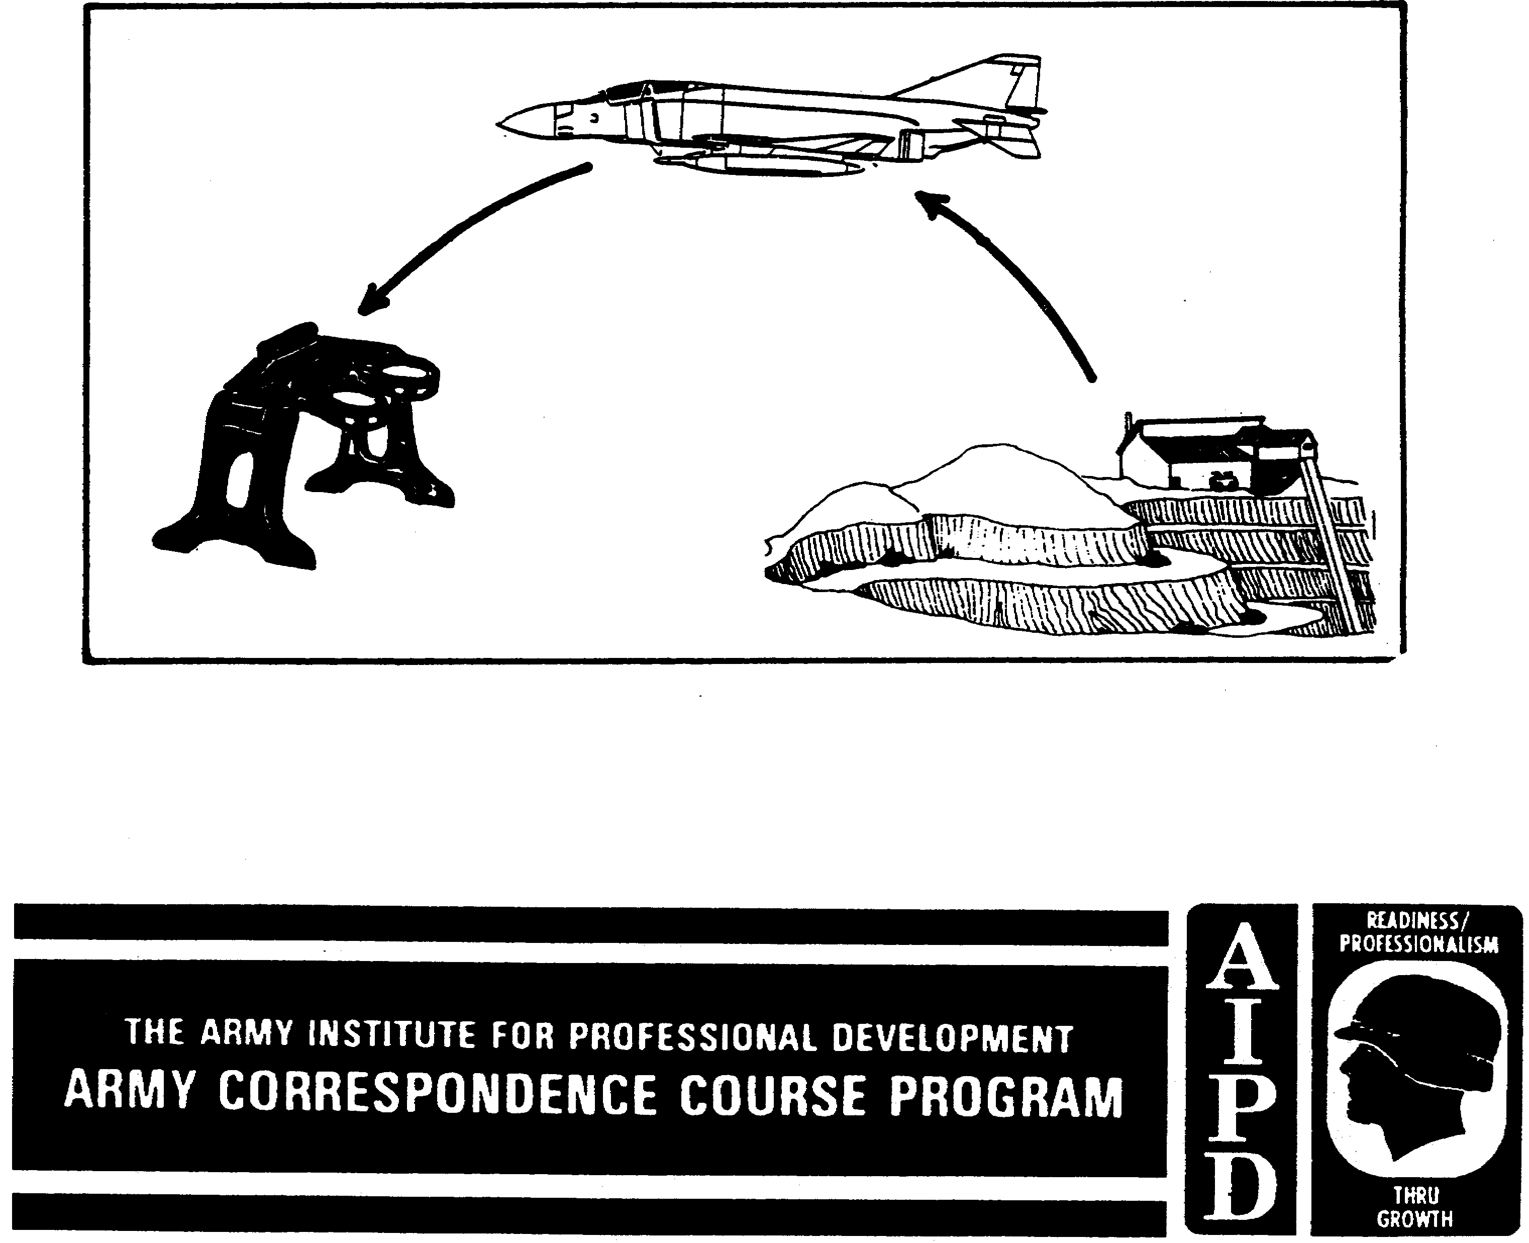

ANALYZE INDUSTRIES IN GENERAL AND EXTRACTION INDUSTRIES ON AERIAL IMAGERY

Subcourse Number IT0672

Edition A

US Army Intelligence Center and School
Fort Huachuca, AZ 85613-7000

2 Credit Hours

Edition Date: September 1991

SUBCOURSE OVERVIEW

This subcourse is designed to teach you basic procedures involved with identifying industries in general and analyzing extraction industries.

Contained within this subcourse is instruction on how to identify industries in general and to analyze extraction industries.

There are no prerequisites for this subcourse.

This subcourse reflects the doctrine which was current at the time the subcourse was prepared.

TERMINAL LEARNING OBJECTIVE

TASK: You will identify procedures for identifying industries in general and analyzing extraction industries.

CONDITIONS: You will have access to extracts from FM 30-10, STP 34-96D24-SM-TG, and TM 30-260.

STANDARDS: You will identify industries in general and analyze extraction industries in accordance with FM 30-10, STP 34-96D-SM-TG, and TM 30-260.

NOTE: Replace the following pages with attached glossy photo pages for better viewing: 22, 23, 25--29, 32, 34, 35, 38, 44--49.

i IT0672

TABLE OF CONTENTS

Section Page

Subcourse Overview

Lesson 1: Identify Processing Industries in General 1
Part A: General Identification Features of Industries 2
Part B: General Image Components of Industries 3
Part C: Major Industrial Categories 4
Practice Exercise 10
Answer Key and Feedback 12

Lesson 2: Analyze Extraction Industries 13
Part A: Extraction Industries in General 14
Part B: Analyzing Extraction Industries 20
Practice Exercise 37
Answer Key and Feedback 40

IT0672 ii

LESSON ONE

IDENTIFY PROCESSING INDUSTRIES IN GENERAL

MOS Manual Tasks: 301-338-2804
301-338-3701

OVERVIEW

TASK DESCRIPTION:

In this lesson you will learn how to identify processing industries in general.

LEARNING OBJECTIVE:

ACTIONS: Describe the information and procedures required to identify processing industries in general.

CONDITIONS: You will be given access to extracts from FM 30-10, STP 34-96D24-SM-TG, and TM 30-260.

STANDARDS: Identification of processing industries in general will be in accordance with FM 30-10; STP 34-96D24-SM-TG, and TM 30-260.

REFERENCES: The material contained in this lesson was derived from the following publications:

FM 30-10.
STP 34-96D24-SM-TG.
TM 30-260.

INTRODUCTION

Processing industries are those which subject the accumulated raw materials from extraction industries to mechanical, chemical, or heat treatment industries.

1 IT0672

PART A: IDENTIFICATION FEATURES OF INDUSTRIES IN GENERAL

1. The term industry includes those establishments engaged in the extraction of raw materials, the processing of these same materials, and the production of intermediate and finished products, as well as certain utilities and services useful to the civilian and military economy.

2. Nearly all major industrial facilities, regardless of function, have certain common physical features that are specifically characteristic. The ability of the imagery analyst (IA) to recognize these features and characteristics will greatly aid in identifying the facility as an industry, and may further aid in the specific identification of the type of industry. Among those features of industrial facilities which are commonly identifiable on aerial photography are:

a. Fuel reserves. Depending upon the type of fuel consumed at the facility, you may observe:

(1) Coal storage piles (black even texture).

(2). Petroleum storage tanks (revetted).

(3) Nearby hydroelectric generation facilities (usually adjacent to a waterfalls or dam).

(4) Electrical transfer facilities (substations, transformers, etc.).

b. Water source(s). Many industrial facilities require enormous quantities of water for generating steam, cooling, and for disposal of effluents (waste by-products). The alert IA may observe:

(1) Adjacent or nearby rivers, streams, or canals.

(2) Lakes or ponds.

(3) Oceans or seas.

(4) Bays, harbors, or estuaries (tributaries of oceans, seas, or lakes).

c. Waste processing or disposal facilities. Many of the waste by-products of industrial operations are treated on site prior to disposal. Imagery may indicate the presence of:

(1) Settling tanks or ponds.

(2) Waste treatment tanks or ponds.

(3) Waste reprocessing areas.

IT0672 2

d. Stacks, chimneys, vents and coolers. Most heavy processing industrial facilities require steam, furnaces, boilers, ovens, or stoves for production. These plants are identifiable by the presence of tall stacks for disposal of gases, steam, smoke, or other consumed lighter-than-air effluents.

e. Transportation access facilities. All industries require some access for transporting raw materials to the facility for production or consumption (in the case of fuel), and for shipment of the finished product from the facility. You may observe any of the following transportation facilities at an industrial complex:

(1) Railroads. Large industries usually have access by railroad.

(2) Ports. Those industries located adjacent to large lakes, rivers, or seas will usually have ship docking facilities.

(3) Highways. Virtually ALL industries are accessible by highways. Evidence of trailer trucks, flatbeds, or tank trucks will indicate the probable use of such vehicles for industrial transportation purposes.

(4) Airstrips. Some industrial products may be airshipped. Clearly, in such a case, a landing strip or helipad (in the case of helicopters) would be essential.

f. Production or fabrication facilities. Depending upon the type of industry, the production or fabrication buildings are usually identifiable. Fabrication industries are categorized by the buildings which shelter the equipment and materials used in fabrication and assembly, the lack of handling and storage facilities of bulk materials, the lack of outdoor equipment other than cranes, and little visible waste. The most obvious and abundant image components are the buildings-either large or small, simple or complex.

PART B: IMAGE COMPONENTS OF INDUSTRIES IN GENERAL

1. Each industry has a characteristic set of raw materials, equipment, buildings, facilities, waste materials, and end products. You can readily identify some of these components on imagery. However, some components you cannot directly observe; therefore you should rely on inferred clues. These clues include the shape or position of buildings, type and number of stacks, type of waste material, etc.

2. Most of the time the IA can identify an industrial facility from image components. However, this task is often complicated. First, not all industries are completely identifiable from their external appearance since some industries do not manifest enough observable image components to classify them as specific types. Second, the appearance of an industrial facility is often complicated by the presence of coincidental

3 IT0672

structures. Small workshops, storage, and administrative buildings, which only peripherally touch upon the primary industrial processes, tend to clutter a site and may be confused with the essential image components.

NOTE: An IA must quickly learn to distinguish the essential from the nonessential and deduce the nonobservable from the visible in order to arrive at a set of viable image components.

3. Furthermore, there are four external recognition factors to consider when identifying industries:

a. Location of the industry.

b. Input or raw material (storage).

c. Facilities (buildings, handling and support equipment, transportation, processing equipment, and facilities).

d. End (finished) products.

PART C: MAJOR INDUSTRIAL CATEGORIES

1. You can place all industries into one of the three major categories: extraction, processing, and fabrication. Additionally, electric power industries are considered as processing industries, although they are serving all industries. The following keys are to get you into the ballpark when identifying the general industrial categories: Industry input materials key (Figure 1-1), industry outdoor equipment key (Figure 1-2), and the bulk and waste materials identification key (Figure 1-3).

2. You can identify industries in general from input materials by following along the "wiring diagram" (Figure 1-1). For example, if no input materials are obvious, the line leads to an extraction industry. If there are variable input quantities and structures, especially small buildings, you can probably determine a fabrication industry from these indicators. In case there are large quantities of input materials and structures, such as large complex buildings and dams, you should identify a processing industry.

IT0672 4

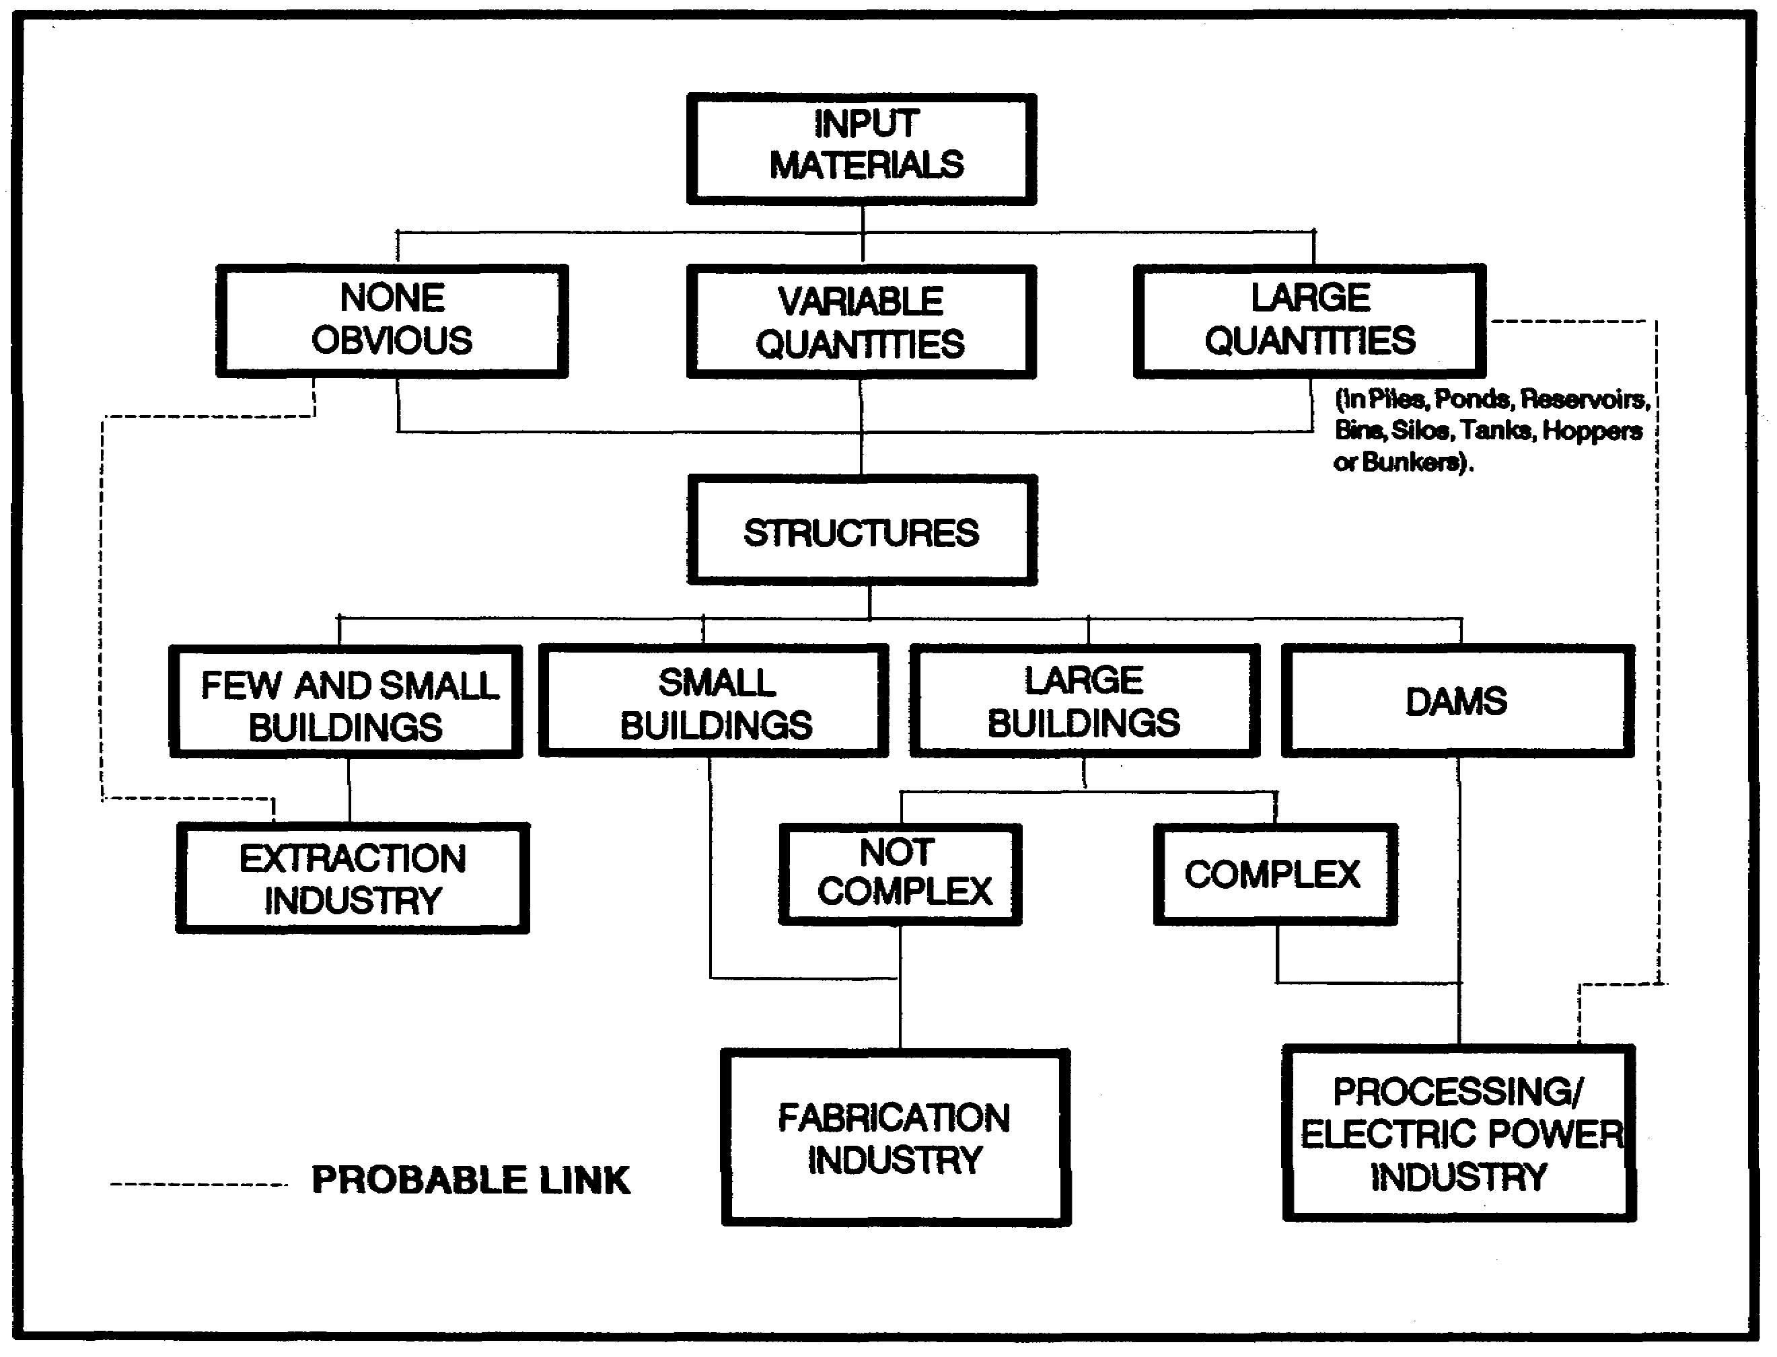

Figure 1-1. Industry Input Materials Key.

3. You can determine industries in general from the identification of outdoor equipment (Figure 1-2) by following along the "wiring diagram." For example, if you identify power shovels, bulldozers, or mine cars on the imagery, you will probably find an extraction industry. Outdoor equipment such as furnaces, cranes, or kilns lead you to a processing industry. This is further broken down into chemical, heat, and mechanical industries. Small amounts of outdoor equipment will lead you to a fabrication industry and further on to heavy and light fabrication.

4. The bulk and waste material identification key (Figure 1-3) consists of a photo color/tone chart in relationship to its major industry. You can also use it in the analysis of industries as further explained in the subcourse.

5 IT0672

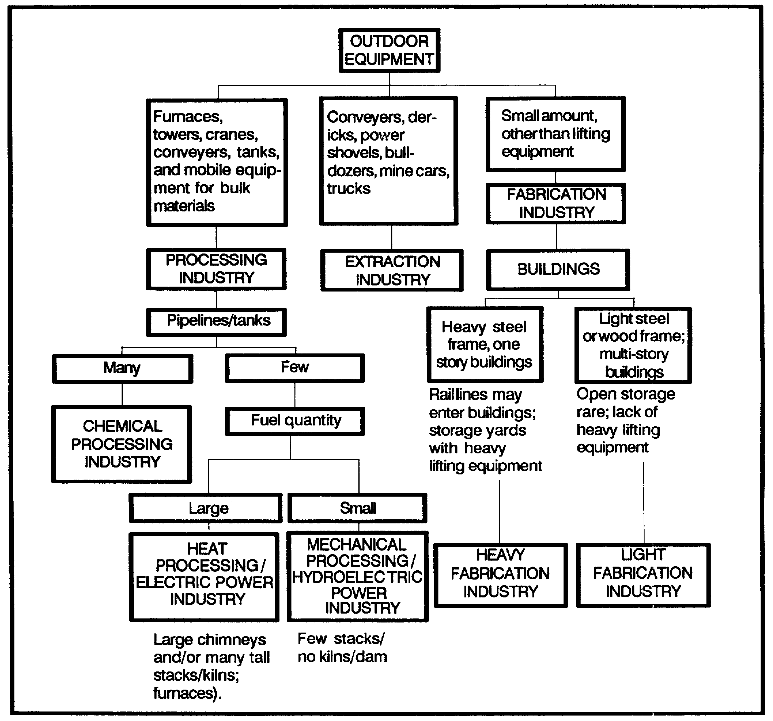

Figure 1-2. Industry Outdoor Equipment Key.

IT0672 6

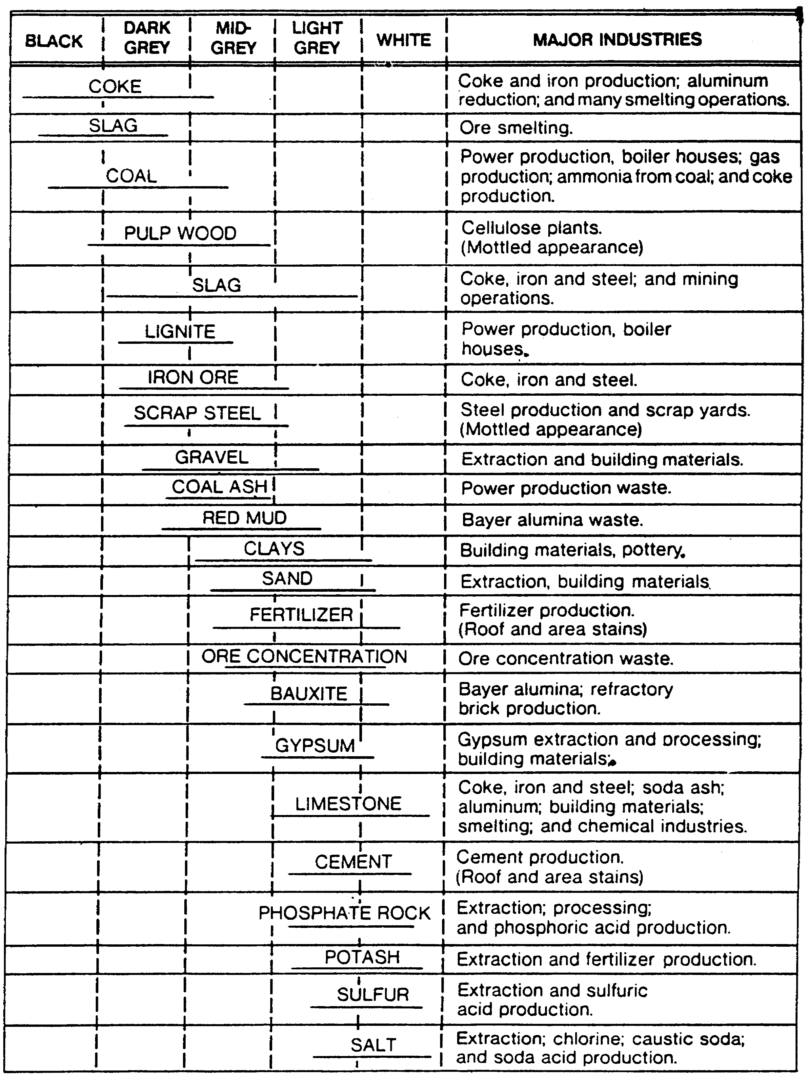

Figure 1-3. Bulk and Waste Materials Identification Key.

7 IT0672

5. You can identify electric power industries by the energy source and structures. Most of these lead to heat processing except for water leading to mechanical processing (Figure 1-4).

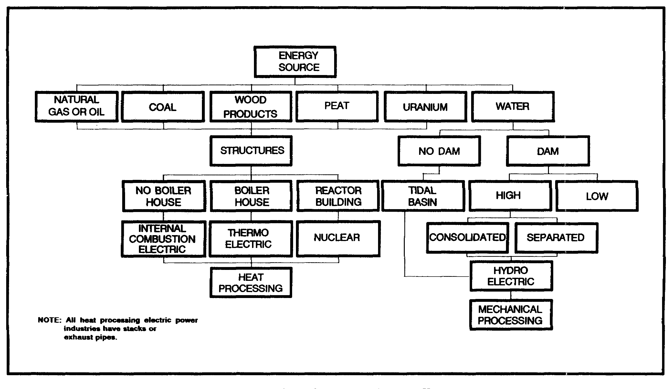

Figure 1-4. Electric Power Key.

IT0672 8

LESSON ONE

PRACTICE EXERCISE

The following material will test your grasp of the material covered in this lesson. There is only one correct answer for each item. When you have completed the exercise, check your answers with the answer key that follows. If you answer any item incorrectly, study again that part of the lesson which contains the portion involved.

1. What are the major categories of industries?

A. Chemical, heavy, and light.

B. Extraction, processing, and fabrication.

C. Heat and mechanical.

D. Nuclear, waste, and hydroelectric.

2. What type industry contains large complex buildings?

A. Electric power.

B. Extraction.

C. Fabrication.

D. Processing.

3. Which color or tone is indicative of limestone on imagery?

A. Light grey to white.

B. Mid grey to dark grey.

C. Black to dark grey.

D. White to black.

IT0672 10

4. In which industry can you identify the use of limestone?

A. Bayer alumina.

B. Ore smelting.

C. Chemical.

D. Fertilizer.

5. Which facilities indicate the presence of settling tanks or ponds?

A. Ports.

B. Electric transfer.

C. Fuel reserve.

D. Waste processing.

11 IT0672

LESSON ONE

PRACTICE EXERCISE

ANSWER KEY AND FEEDBACK

Item Correct Answer and Feedback

1. B. The major categories of industries are extraction, processing, and fabrication (page 4, part C, para 1).

2. D. Processing industries contain large complex buildings (page 5, fig 1-1).

3. A. Limestone shows up light grey to white on imagery (page 7, fig 1-3).

4. C. You should be able to identify limestone in chemical industries (page 7, fig 1-3).

5. D. The presence of settling tanks or ponds indicate waste processing facilities (page 2, para 2c(1)).

IT0672 12

LESSON TWO

ANALYZE EXTRACTION INDUSTRIES

MOS Manual Tasks: 301-338-2804
301-338-3701

OVERVIEW

TASK DESCRIPTION:

In this lesson you will learn to analyze extraction industries.

LEARNING OBJECTIVE:

ACTIONS: Describe the information and procedures required to analyze extraction industries.

CONDITIONS: You will be given access to extracts from STP 34-96D24-SM-TG and TM 30-260, STANDARDS: Analysis of extraction industries will be in accordance with STP 34-96D24-SM-TG and TM 30-260.

REFERENCES: The material contained in this lesson was derived from the following publications:

STP 34-96D24-SM-TG.
TM 30-260.

INTRODUCTION

Extraction industries are those which exploit the natural resources of the earth and its waters with the minimum handling required to accumulate raw materials in a form suitable for transportation or processing. Extraction industries are characterized by excavations in the earth, mine openings, derricks, and ponds. Stores of raw materials and piles of waste (tailings) are common.

13 IT0672

PART A: EXTRACTION INDUSTRIES IN GENERAL

1. The accumulation of raw materials usually entails some preparation, such as crushing to render the material more uniform in size, or preliminary sorting to separate the useful portion from the waste. If these operations take place in the extraction area, the buildings and equipment employed are considered to be part of the extraction industry.

2. The following methods are used in extraction industries:

* Mining

* Quarrying

* Pumping

* Drilling

* Dredging

* Fishing

* Farming

* Wood cutting

a. Mining, quarrying, oil and salt recovery, and dredging are typical of the extraction industries.

b. Various mining methods are employed to extract a great variety of raw materials. Strip mines are used when the ore or materials are in a thin layer near the surface. Open pit mines are common where the material to be extracted lies close to the surface and in a massive body or thick layers.

c. Quarries may resemble open pit mines, but the material extracted consists of rock or other earthen material, rather than coal or ore. Bank or drift mines have a nearly horizontal tunnel into a hillside; shaft mines enter the earth vertically or at a steep angle.

d. Dredges are used to collect sand and gravel, and to extract heavy minerals from placer deposits, as well as to deepen rivers or channels for navigation.

e. The operations and equipment utilized in drilling wells for the recovery of gas, oil, salt and sulfur all are similar. However, salt may be mined or recovered by evaporation in open ponds called salt pans.

IT0672 14

f. Fishing, farming and wood cutting are also functional in the extraction industry. These functions are very important in third world countries for survival alone. However, modernized countries are using entire fishing fleets.

3. Recognition features. Even though you may have excellent photography of an extraction industry, it is usually very difficult to determine the specific industry and end product without ground intelligence. However, the following recognition features or image components (Figure 2-1) will assist you in identifying components of extraction industrial facilities:

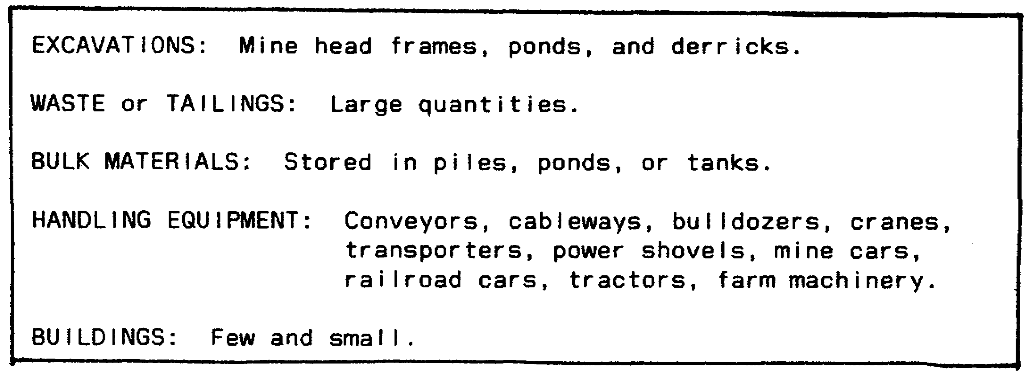

Figure 2-1. Typical Extraction Industry Recognition
Features/Image Components.

NOTE: Most of the above components are also covered in the industry outdoor equipment key (Figure 2-3).

a. Excavations. The scars on the earth's surface which indicate removal of material not only change the topography, but also interrupt the continuity of vegetation and soil tone. The size of the excavation if frequently an indication of the duration of the operation. The size may range from huge open pit mines covering square miles to indistinct bank mine entrances in a hillside. The area disturbed by peat cutting and strip mines may be great although only a thin layer of material is removed.

b. Handling equipment. Tanks found in oil fields may be round covered tanks or open earthen reservoirs. They hold crude oil recovered from the wells until it can be shipped to the refinery. Open oil storage reservoirs are distinguished on aerial photos by their consistently dark tone. Bins and hoppers serve as useful temporary containers for ore, gravel or rock.

(1) In addition to the pipelines associated with oil fields and dredging operations, such other handling equipment as hoists and conveyors are used to carry heavy bulk raw materials and waste. They are most useful where slopes are steep, the terrain is rugged, and where large quantities of bulk materials must be moved between two places

15 IT0672

economically. Hoists are cable-operated devices which transport materials up an incline in cars. Conveyors range in size, length and capacity, and may be a continuous belt inclosed in a housing, or buckets traveling along a cable elevated on supports.

(2) Of the mobile equipment employed in many extraction industries, such heavy equipment as cranes, bulldozers and power shovels is utilized in most of those industries involving excavation. Trucks, or mine cars which may operate on temporary tracks, are used to bring the raw material from the pit, quarry face, or mine.

(3) Complex equipment is not common in the extraction industries. A derrick is erected at the site of a well to handle the pipe and tools while the well is being drilled. Afterwards the derrick commonly is removed. Similar to derricks are the headframes found over shaft mines. A headframe is the structure which supports the cables operating the mine elevator. Sometimes the framework is apparent, other times the headframe is roofed or completely inclosed. If no waste is piled nearby, the headframe may be the only indication of a shaft mine.

c. Buildings are few and small, or even lacking in the extraction industries. They rarely serve functions essential to these industries, and therefore are not very useful to the IA. Buildings may shelter crushing and screening equipment, they may be used to store mobile equipment or explosives, or they may house personnel. On occasion administration buildings and workshops for repairing equipment will be seen.

d. Open storage and waste may appear as either piles or ponds. Large piles of waste often are associated with the extraction industries, especially mining, because it is necessary to remove large quantities of worthless material to get out the ore or other useful material. Stored raw materials usually can be distinguished from piles of waste since the waste is dumped in an area and in such a manner that makes further handling difficult and accumulates there in ever-increasing quantities. The raw materials, however, always are placed in a readily accessible location, usually near a rail line or road, and stored in such a way that they can be economically transshipped. Artificial ponds may be used to hold liquids such as crude oil or brine for salt extraction.

NOTE: Excavations, if present, are the most significant class of image components for this category. Open storage and waste also will be valuable in identifying an industry. Equipment for handling bulk materials, such as conveyors, hoists and cranes, aid in analyzing the succession of operations. Complex equipment, such as headframes and derricks, at times are the only evidence of an extraction industry to be seen on aerial imagery.

IT0672 16

4. Inspect the industry input materials key for extraction industries (Figure 2-2). The key shows there are either FEW and SMALL BUILDINGS or in some cases there are NONE OBVIOUS. In the latter case, these materials originate from materials or cultivated environment and unless activity is present, they would appear as total features of terrain. However, when identifying crops or planted forests where a definite pattern can be noted, input materials are obvious.

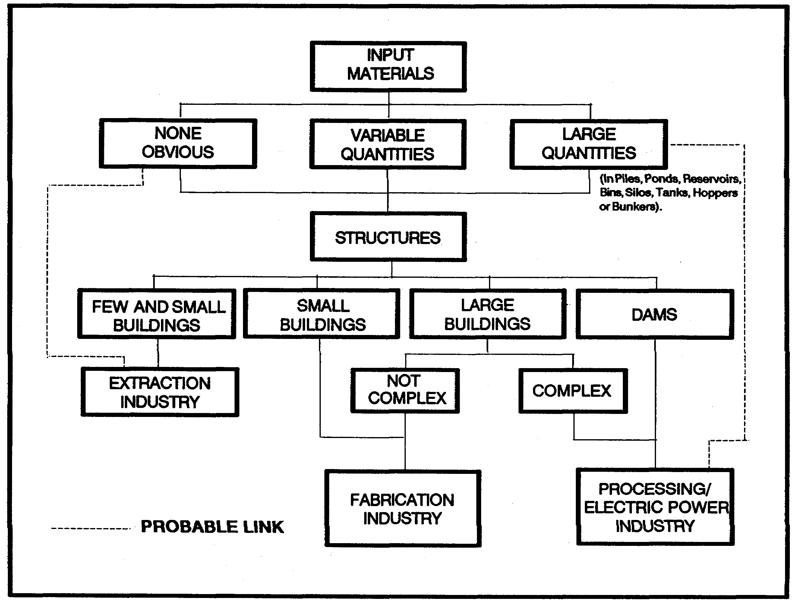

Figure 2-2. Industry Input Materials Key.

17 IT0672

5. Examine the industry outdoor equipment key for extraction industries (Figure 2-3). Note the typical extraction industrial equipment which can be observed outdoors, including conveyors, derricks, power shovels, bulldozers, mine cars, and so on.

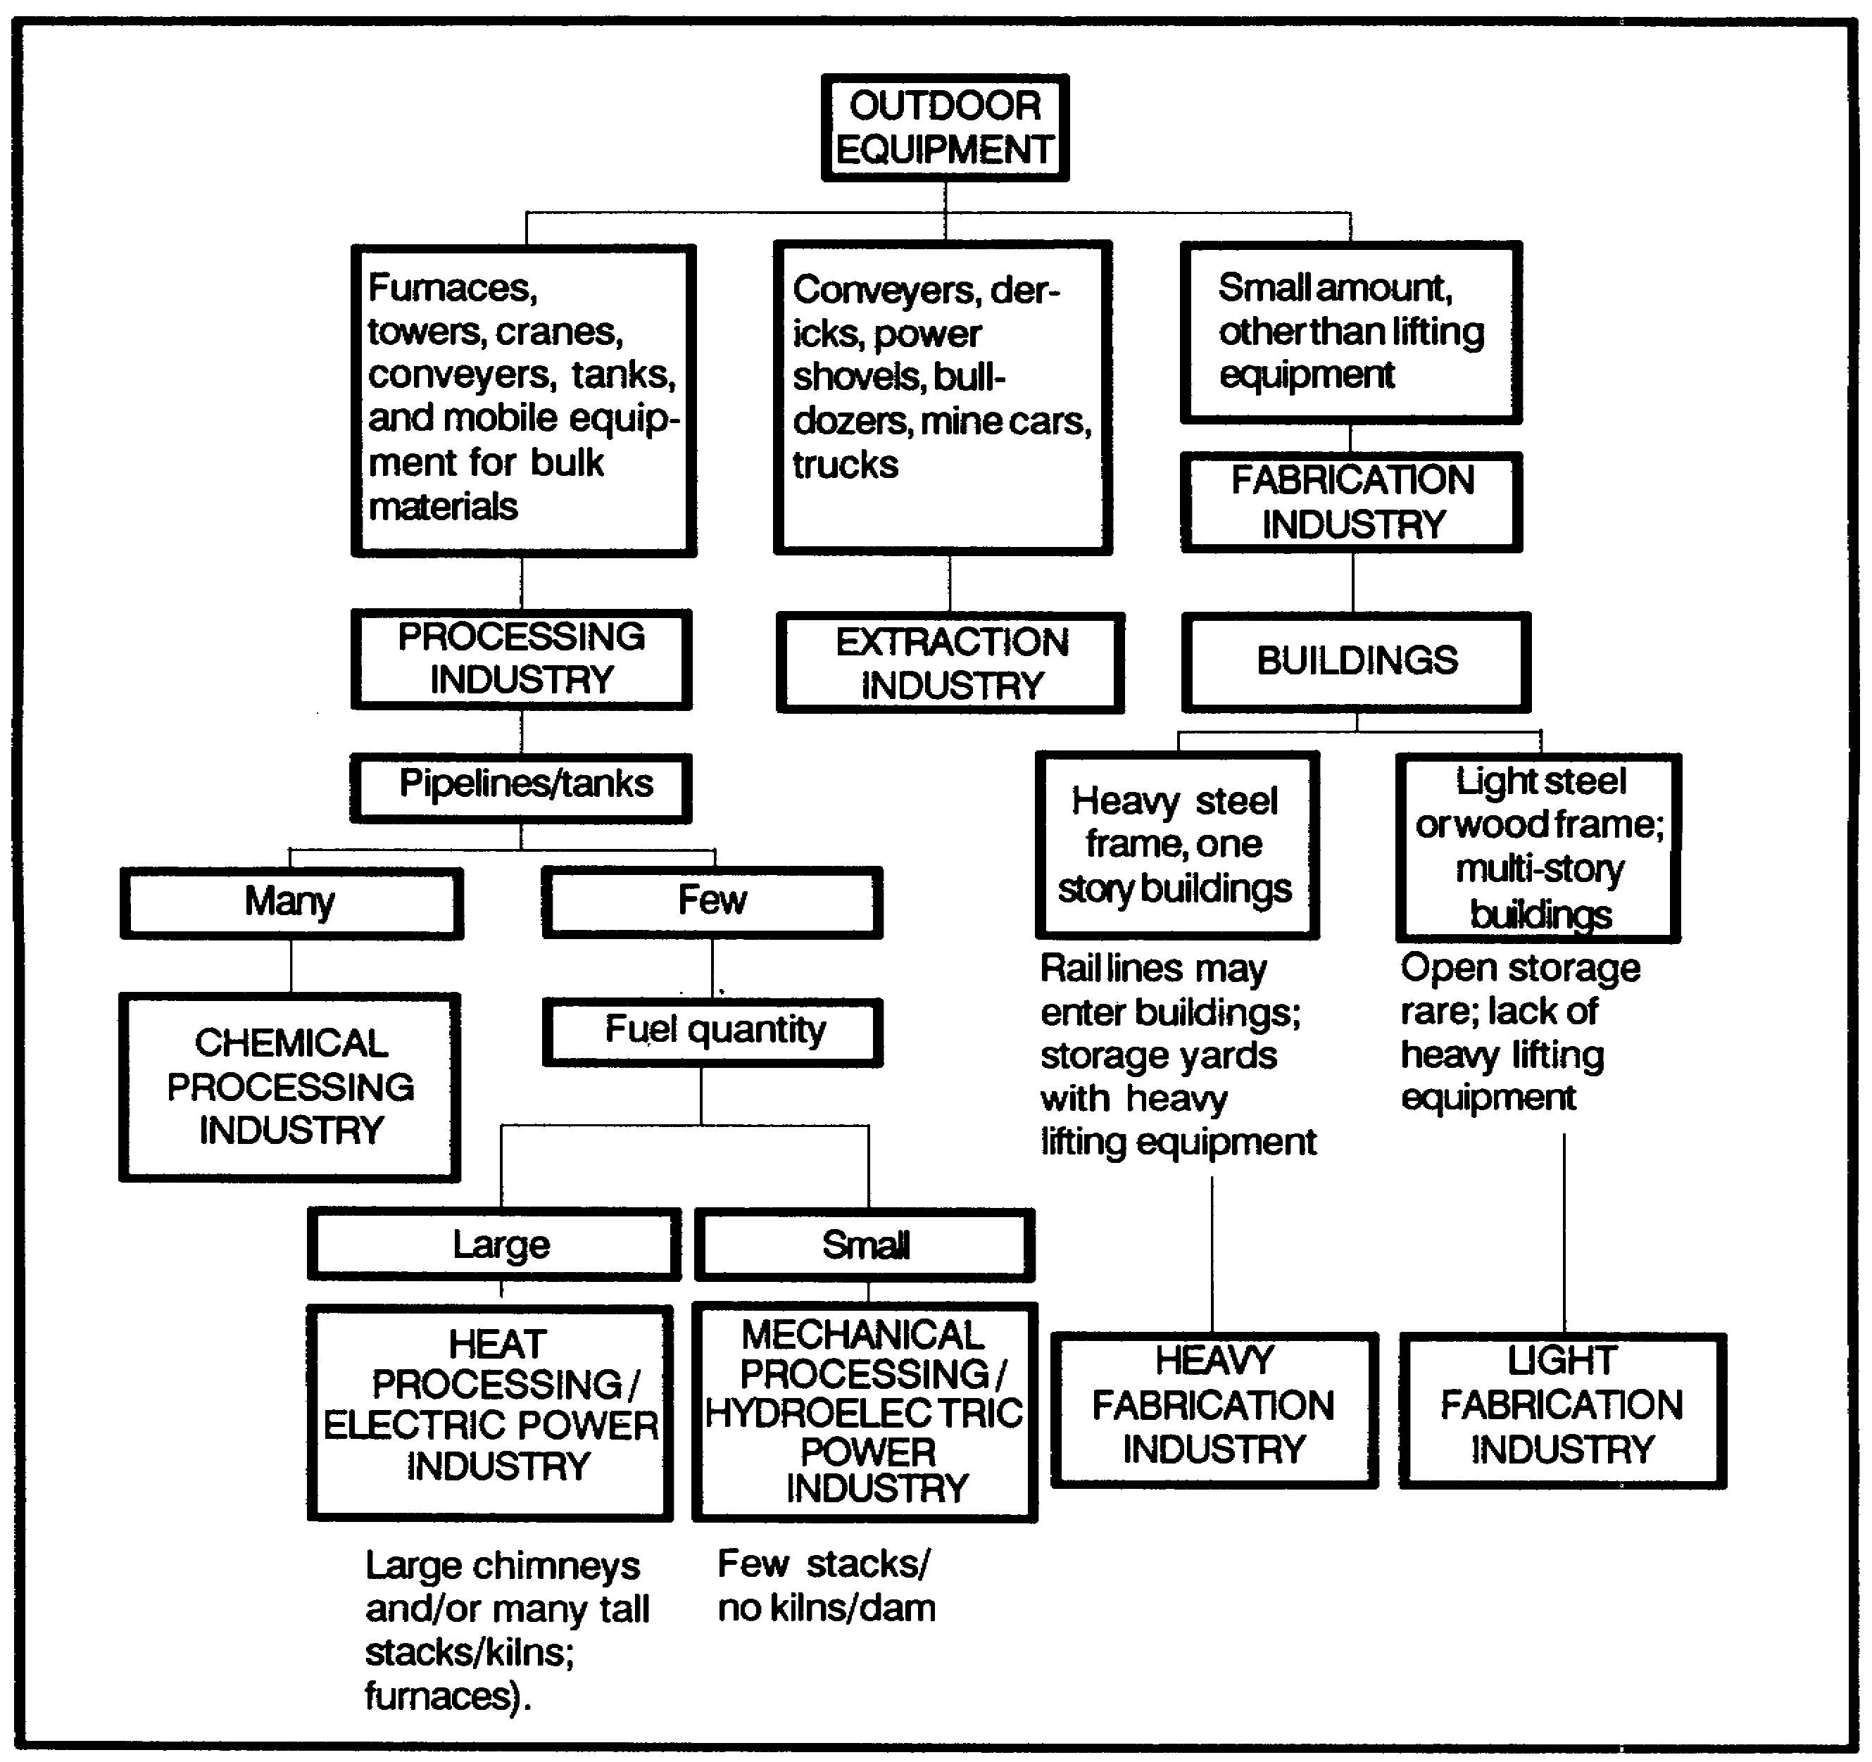

Figure 2-3. Industry Outdoor Equipment Key.

6. The bulk and waste materials identification key (Figure 2-4) will assist you in the identification of bulk materials and waste by comparing the tone of the photo. This key is especially helpful in determining the end products of extraction industries.

IT0672 18

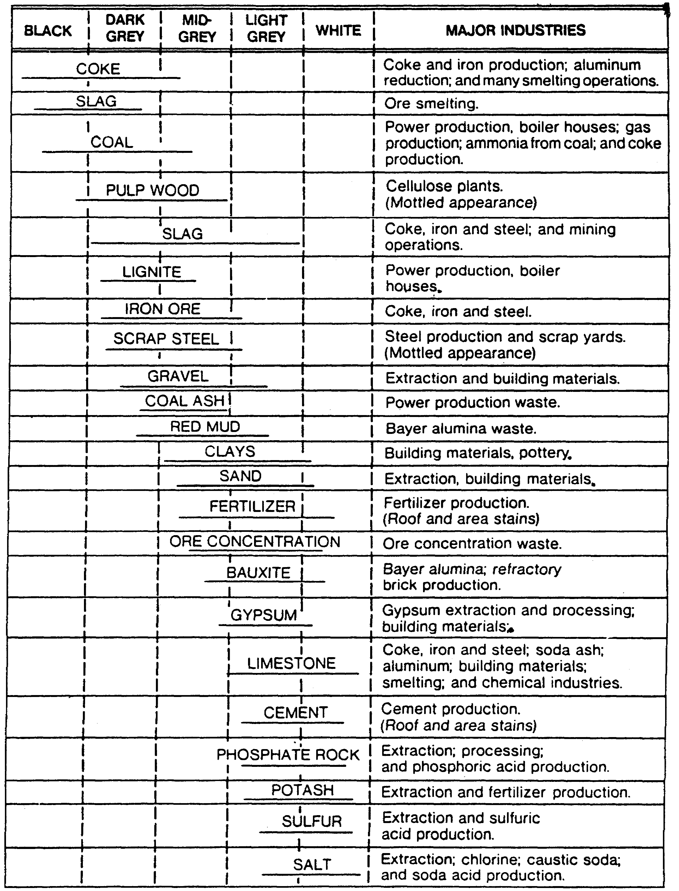

Figure 2-4. Bulk and Waste Materials Identification Key.

19 IT0672

PART B: ANALYZING EXTRACTION INDUSTRIES

1. Extraction industries involve the obtaining of solid, liquid, and gaseous raw materials including ores, minerals, natural gas, oil, timber, and food from their natural or cultivated environments. The raw materials are then transported and most of them are processed. The end product of an extraction industry is normally the in product of a processing industry. Figure 2-5 further clarifies the relationship of the industrial category through the extraction method to the end product.

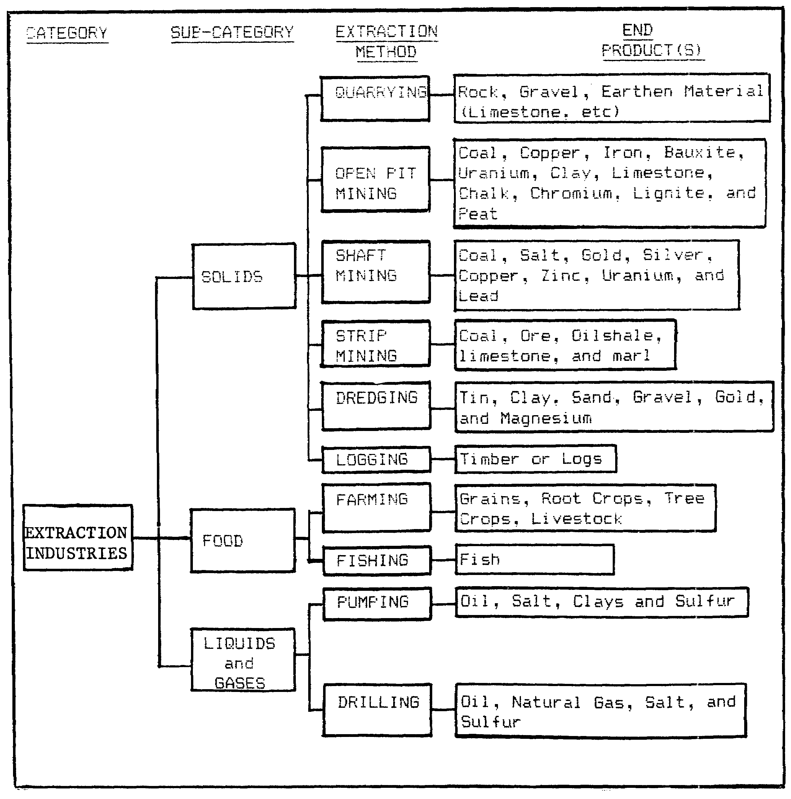

Figure 2-5. Extraction Industry Analysis.

IT0672 20

2. You should consider the factors, to include location, raw materials, extraction method, and the end product in analyzing extraction industries. Additionally, you should consider the production flow (Figure 2-6).

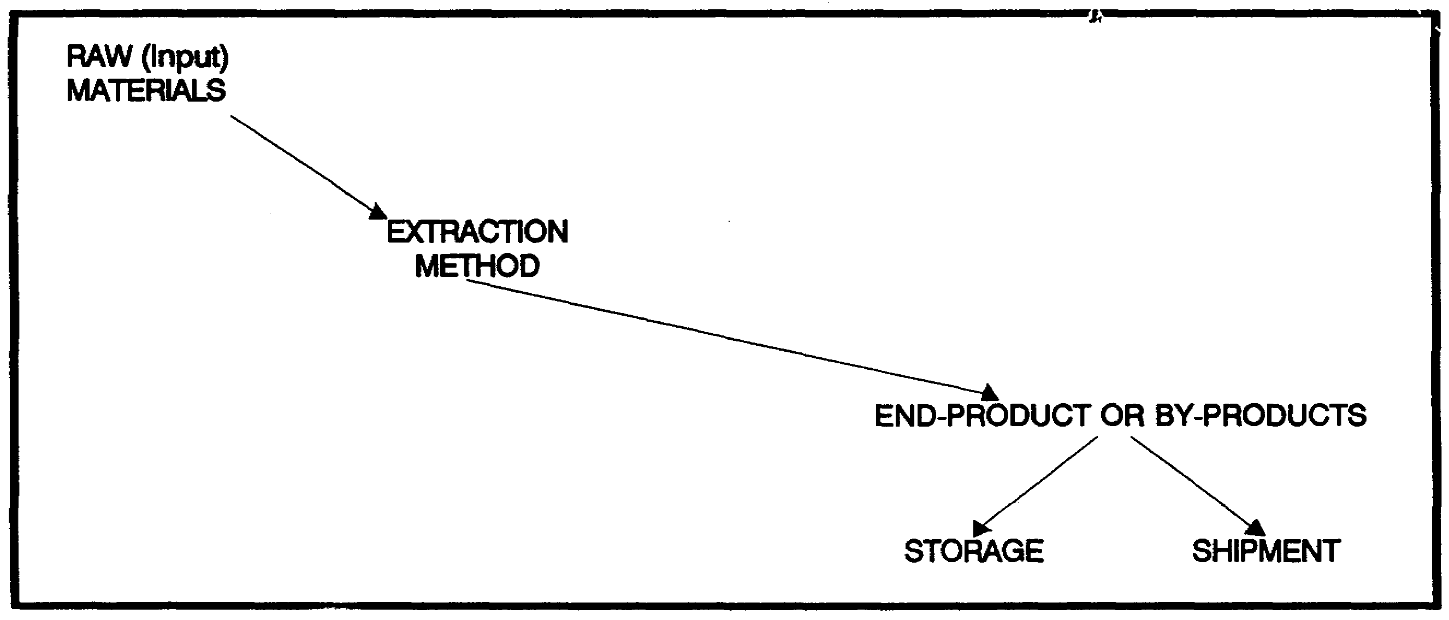

Figure 2-6. Production Flow.

3. The following illustrations and photos depict typical extraction industries. You should notice the end products in relationship to their extraction method and compare these with the extraction industry analysis (Figure 2-5).

21 IT0672

a. A quarry is an open excavation or pit from which stone is removed by digging, blasting, or cutting. Quarrying is used in extracting the following material:

- Rock or stone

- Gravel

- Earthen material (limestone, etc.)

(1) In a limestone quarry limestone is loaded into trucks by power shovels, transported to the top of the quarry, and conveyed to the crushing buildings. After being crushed and screened to size it is stored in piles awaiting shipment (Figure 2-7).

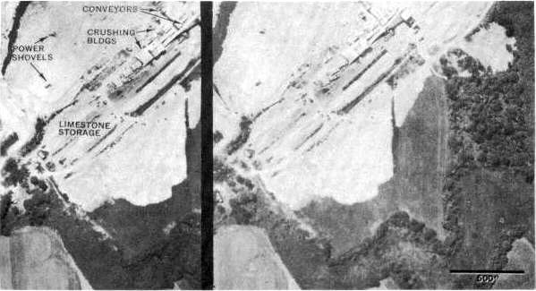

Figure 2-7. Limestone Quarry.

IT0672 22

(2) In a gravel pit or quarry, bulldozers are used to scrape gravel from the stream bed. A power shovel digs the gravel from the banks and loads it into trucks to be dumped into a bin. Other trucks are loaded beneath the bin and transport the gravel elsewhere for use (Figure 2-8).

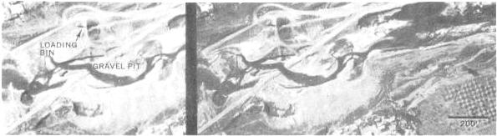

Figure 2-8. Gravel Pit.

b. In open pit mining (Figure 2-9) the following solids are extracted:

• Coal • Clay • Limestone

• Bauxite • Copper • Peat

• Chalk • Iron • Uranium

• Chromium • Lignite

23 IT0672

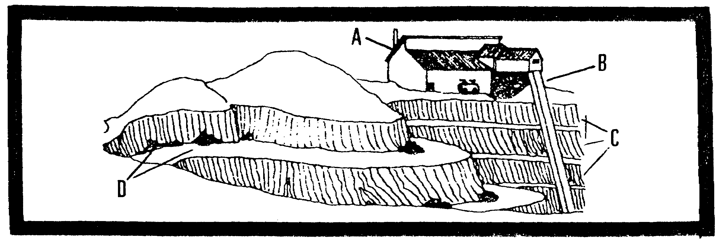

Figure 2-9. Open Pit Mining.

Legend:

A - Crushing and grinding building
B - Closed conveyor belt
C - Extraction material
D - Tailings

IT0672 24

(1) A typical open pit ore mine is depicted in Figure 2-10.

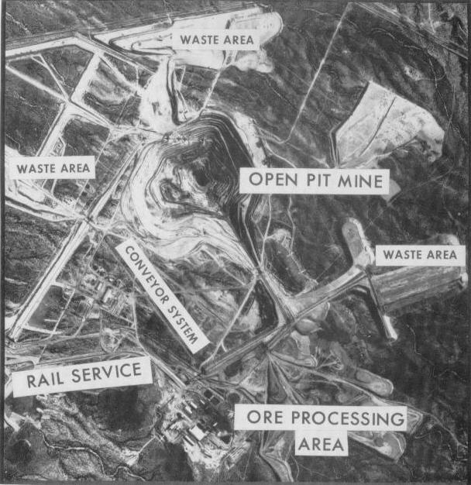

Figure 2-10. Open Pit Ore Mining.

25 IT0672

(2) In an open pit coal mine coal is being extracted on four levels. Mine cars carry the coal to bins from which it is dumped into hoist cars. These cars transport the coal to the hoist building, and a conveyor carries it to the railcar-loading building (Figure 2-11).

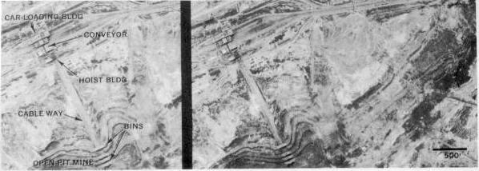

Figure 2-11. Open Pit Coal Mine.

(3) In an open pit chromium mine a round depression has been excavated in the valley floor. To prevent flooding, a diversion dam was constructed, and a tunnel in the hillside carries the stream around the site of the mine. The ore is dug by a power shovel and transported by rail (Figure 2-12).

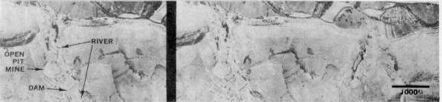

Figure 2-12. Open Pit Chromium Mine.

IT0672 26

c. In shaft mining (Figure 2-13) the following solids are extracted:

• Coal • Gold • Salt • Uranium

• Copper • Lead • Silver • Zinc

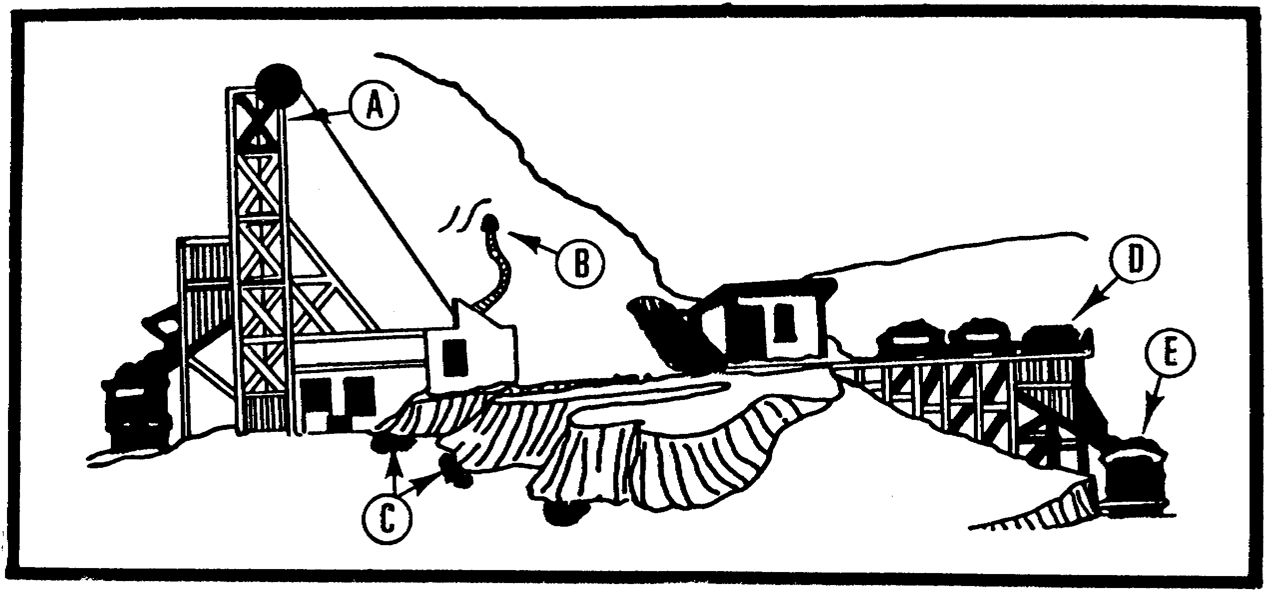

Figure 2-13. Shaft Mining.

Legend:

A - Headframe D - Ore cars
B - Horizontal mine shaft E - Gondola or hopper cars
C - Tailings

(1) In shaft coal mining operations, coal and waste rock are brought out of a mine by a cable hoist. The waste is dumped nearby while the coal is transported away by railcar (Figure 2-14).
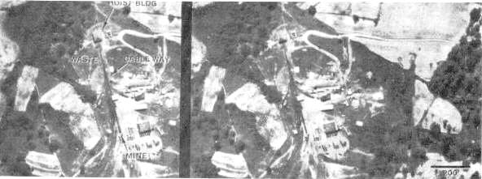

Figure 2-14. Shaft Coal Mining Operation.

27 IT0672
(2) In shaft ore mining, ore and waste are carried in mine cars to the trestle where the ore is dumped into railcars. The waste pile is nearby. In Figure 2-15 the mine was started as an open pit, but surface mining was abandoned when the overburden became too thick, and tunnels or shafts were driven into the face of the pit.

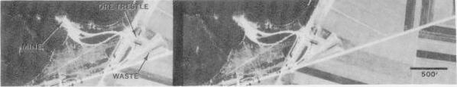

Figure 2-15. Shaft Ore Mining Operation.

(3) Processing of shaft mining end products takes place at distant sites; therefore, certain transportation is required which can be related for identification purposes, i.e. mine cars (Figure 2-16) and overhead cableways (Figure 2-17).

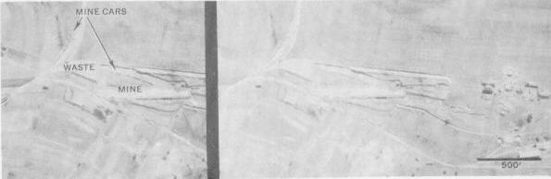

Figure 2-16. Shaft Mining Related Transportation.

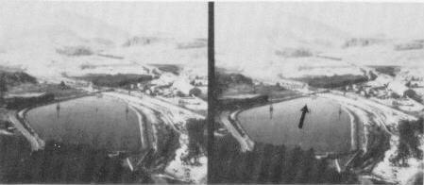

Figure 2-17. Overhead Bucket Conveyors over Pond.

IT0672 28

d. In strip mining the following solids are extracted:

• Coal • Marl

• Oil shale • Ore

• Limestone

(1) In oil shale strip mining the shale lies close to the surface in a thin bed. The overburden is stripped away, the shale extracted, and the overburden replaced in parallel mounds over the exhausted area (Figure 2-18).

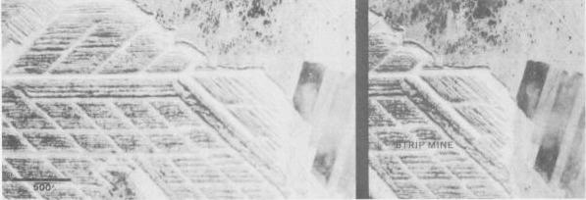

Figure 2-18. Oil Shale Strip Mining.

(2) In limestone strip mining, limestone is stripped in a fanlike pattern. The mine in Figure 2-19 has been abandoned and is overgrown with vegetation and partly filled with water. Current mining operations are some distance away. Rail lines transport the material to the barge -loading area.

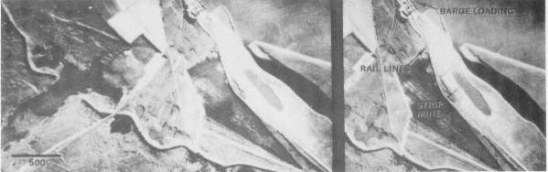

Figure 2-19. Limestone Strip Mining.

29 IT0672

e. Dredging is the process of extracting solids from their natural environments. Dredging or hydrolicking is used to extract the following solids:

• Clay • Gravel • Sand

• Gold • Magnesium • Tin

(1) A typical dredging operation is shown in Figure 2-20.

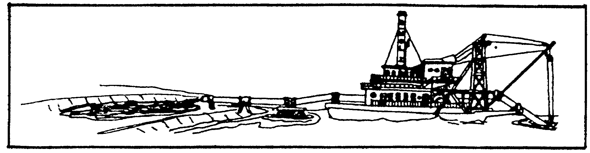

Figure 2-20. Typical Dredging Operation.

(2) Dredging with suction devices or drag buckets is used when ores are found mixed with water in their natural state. Gravel, sand, clay, and other ores are extracted by these methods. Dredges are of the intermittent or continuous class. The intermittent class includes the dipper dredge (Figure 2-21) and grabbing dredge (Figure 2-22). The continuous class includes the ladder dredge (Figure 2-23) and hydraulic dredge (Figure 2-24).

NOTE: Normally, you should find a barge nearby a dredge for hauling the solids off to shore.

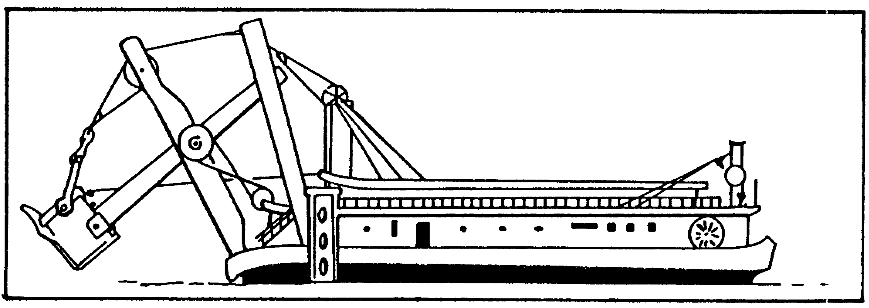

Figure 2-21. Dipper Dredge.

IT0672 30

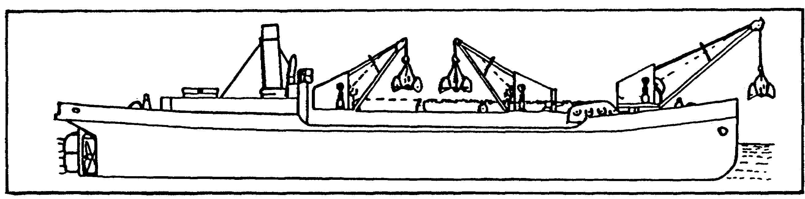

Figure 2-22. Grabbing Dredge.

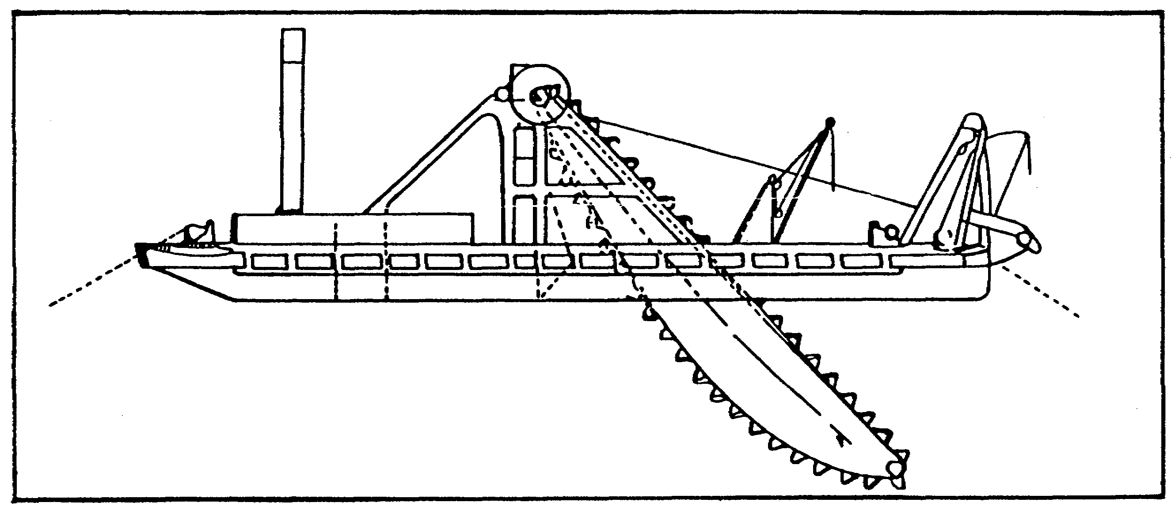

Figure 2-23. Ladder Dredge.

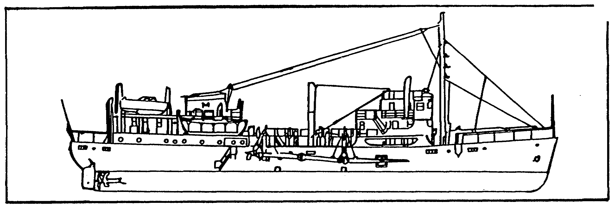

Figure 2-24. Hydraulic Dredge.

31 IT0672

(3) In dredging, sediment is pumped from the bottom and used as fill. The material passes through a floating pipeline from the dredge to the area where the land is being reclaimed (Figure 2-25).

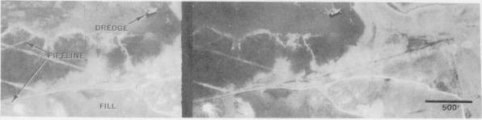

Figure 2-25. Dredging Operation-Reclaimed Land.

(4) Before storing material at a dredging site, sand, gravel, and silt are dredged and screened. Silt is wasted while the sand and gravel are piled for future use (Figure 2-26).

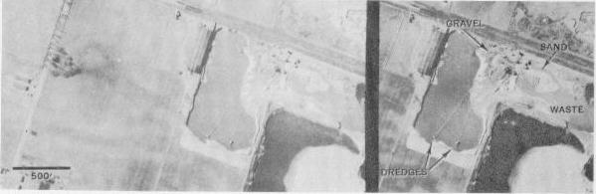

Figure 2-26. Dredging Operation for Building Material.

f. Logging is the process of felling and trimming trees and transporting the logs to a mill via trucks or float. Furthermore, you may identify logs being loaded on ships for overseas shipment. Imagery of this extraction method is not available at this time.

g. Forestry is the art of cultivating, maintaining, and developing forests.

NOTE: The Corps of Engineers is proponent for logging operations and forestry; therefore this production method is not further discussed in this lesson.

IT0672 32

h. Drilling is an operation performed by devices with cutting edges or a pointed end for boring holes, usually by abrasion or repeated blows. Drilling rigs are found on land and offshore. Offshore rigs are primarily used to extract oil. By drilling the following solids and gases are extracted:

• Natural gas • Salt

• Oil ·• Sulfur

(1) Typical drillings rigs are shown in Figure 2-27.

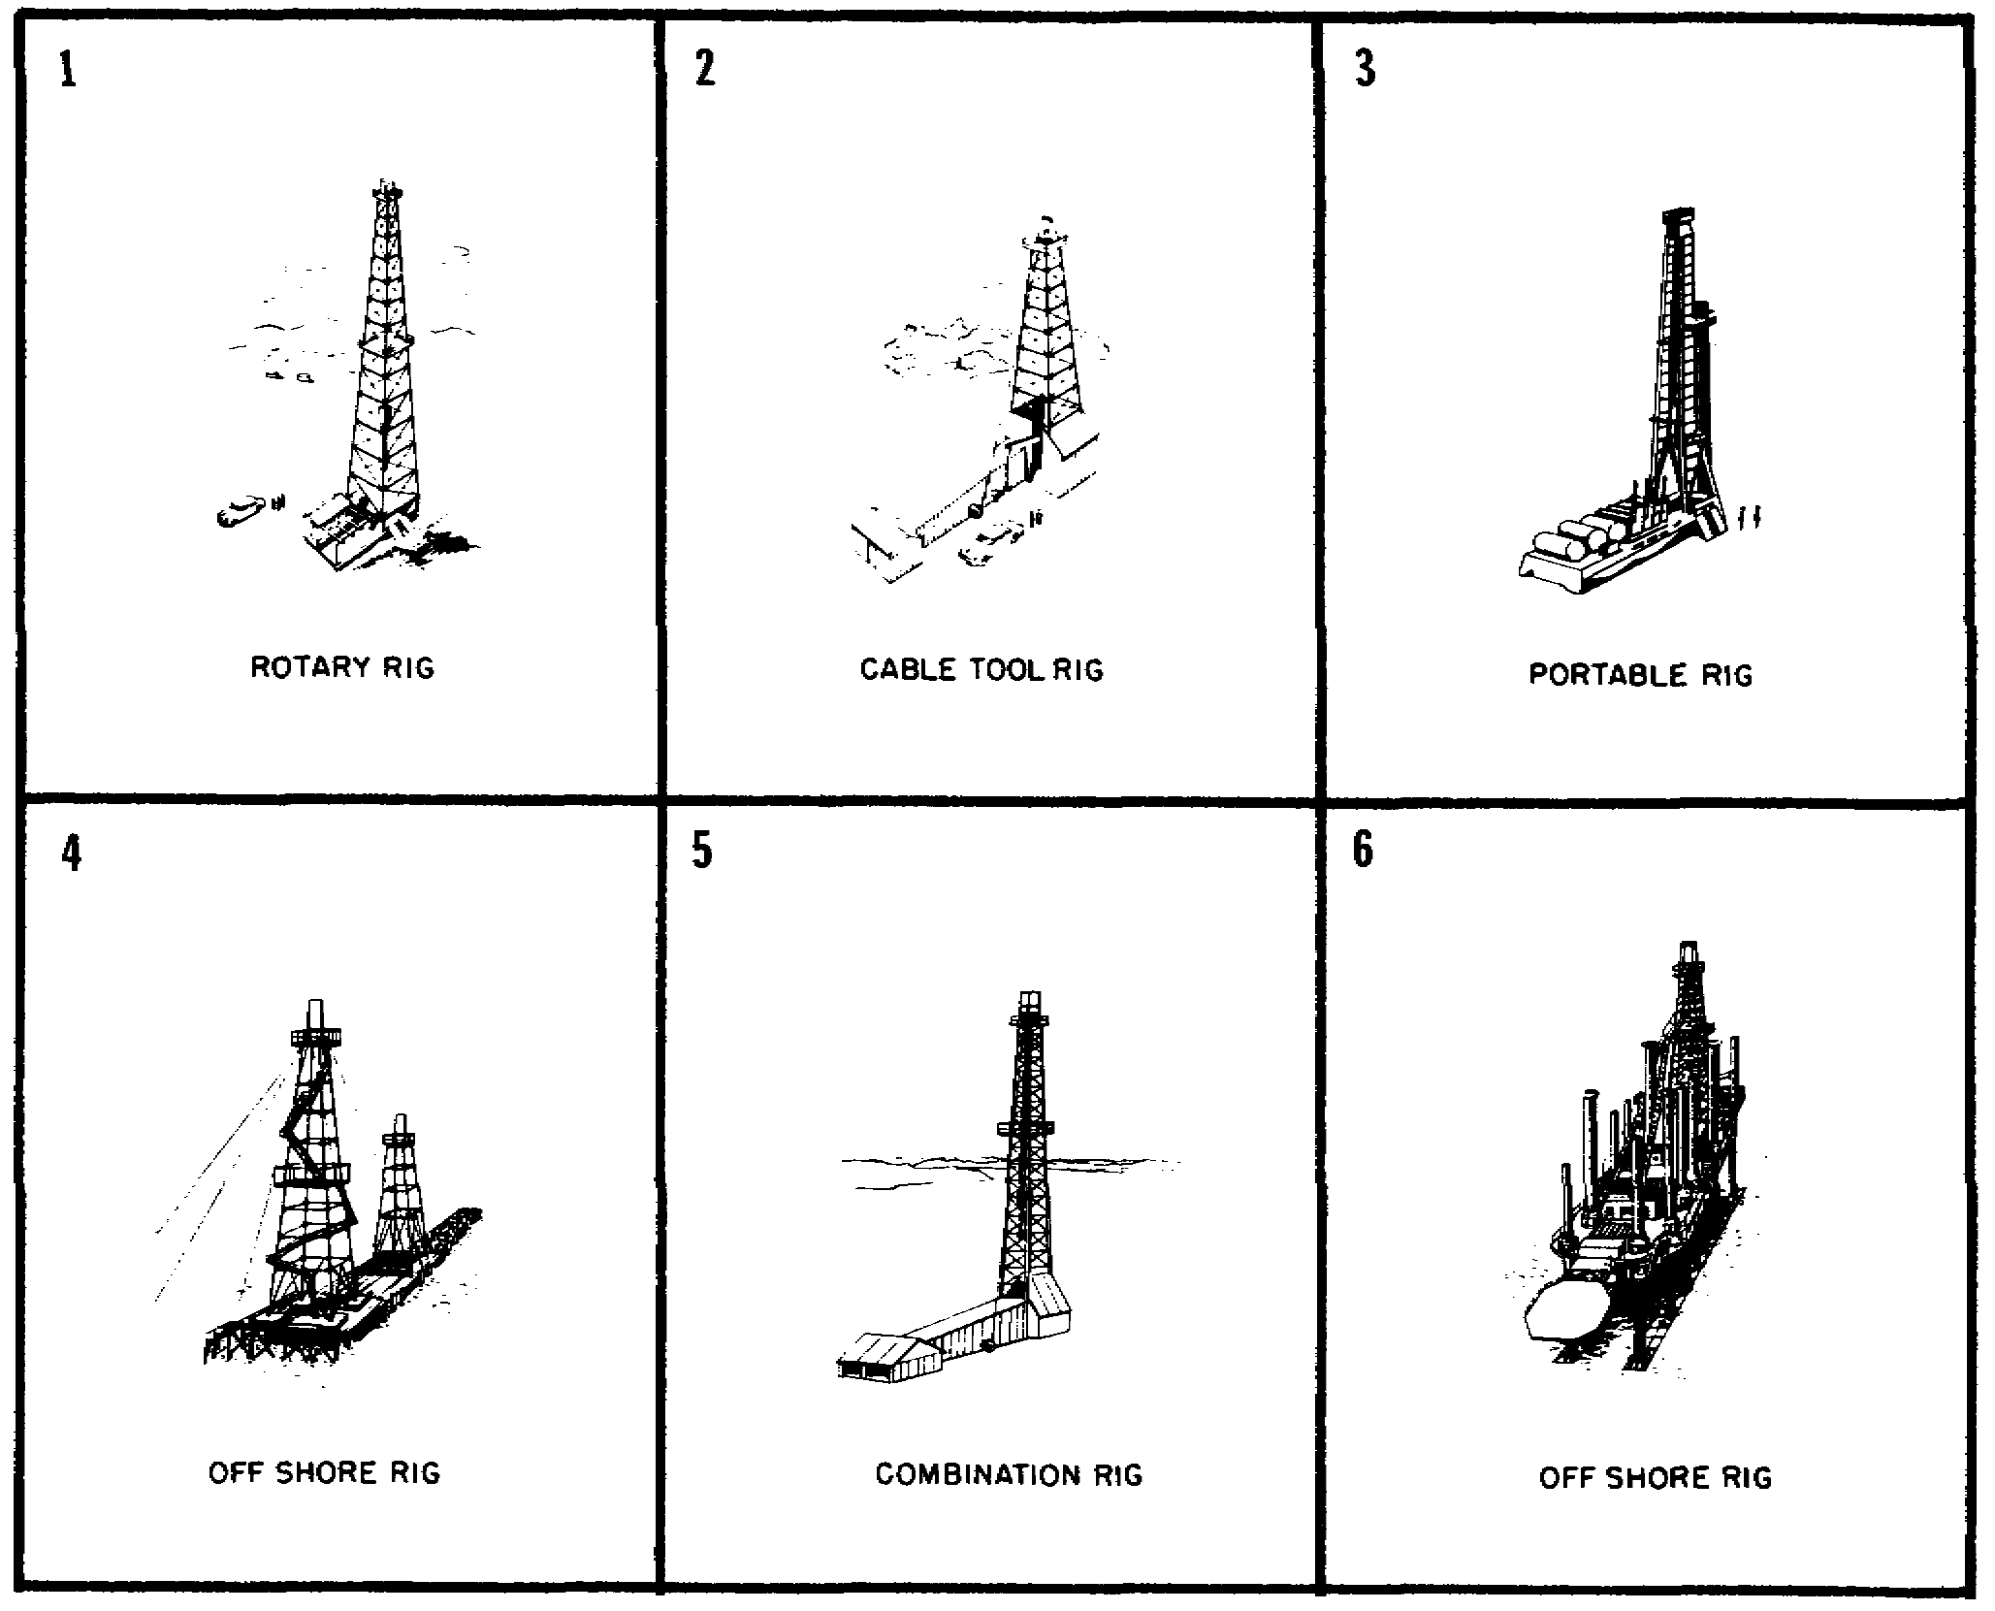

Figure 2-27. Typical Drilling Rigs.

33 IT0672

(2) Derricks, oil pumps, pipelines, open storage, few buildings, tanks, ponds, and access roads normally are related to an oilfield site. The pyramidal steel framework of oil derricks is used to handle pipe and drilling tools as the wells are being drilled. The sump pits hold water used in drilling and catch refuse from this operation: The derrick is sometimes removed after the well is drilled. Reservoirs are used for temporary oil storage (Figure 2-28).

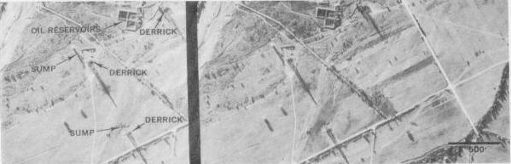

Figure 2-28. Oilfield Site.

i. Pumping is done by a device for transferring liquids and gases from a source or container through pipes to tanks. Liquids are transferred to tanks or settling sumps (Figure 2-29).

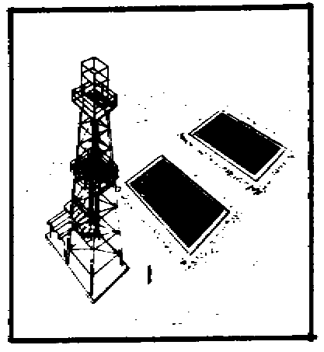

Figure 2-29. Storage and Settling Sumps.

IT0672 34

(1) A typical walking beam oil pump and a hydraulic pump are shown in Figure 2-30 and 2-31.

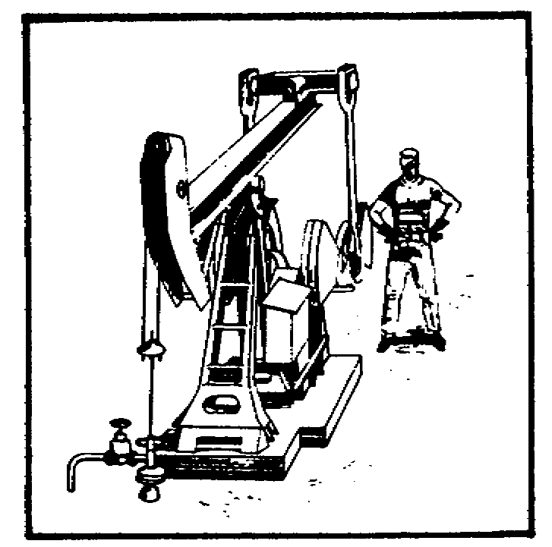

Figure 2-30. Typical Walking Beam Oil Pump.

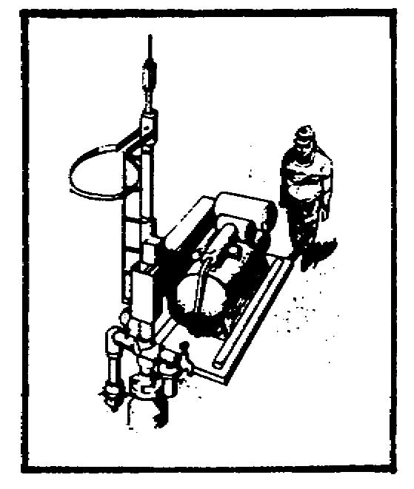

Figure 2-31. Typical Hydraulic Pump.

(2) Oil from wells in the area is accumulated in these storage tanks (Figure 2-32). A pipeline connects them with the railhead which is under construction where the oil will be loaded into tank cars for shipment.

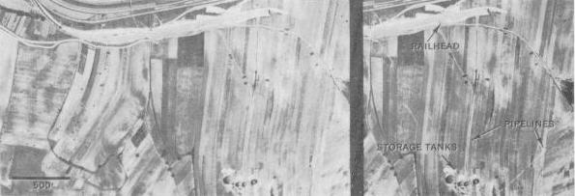

Figure 2-32. Storage Tanks and Pipelines.

35 IT0672

j. Farming is the art of cultivating soil, producing crops, and raising livestock.

k. Fishing is the art of catching fish by hook or net.

NOTE: The Corps of Engineers is the proponent for farming and fishing; therefore these production methods are not further discussed in this lesson.

IT0672 36

LESSON TWO

PRACTICE EXERCISE

The following material will test your grasp of the material covered in this lesson. There is only one correct answer for each item. When you have completed the exercise, check your answers with the answer key that follows. If you answer any item incorrectly, study again that part of the lesson which contains the portion involved.

1. Which color reveals gravel on a black and white photo?

A. Black to dark grey.

B. Dark grey to light grey.

C. Mid grey to light grey.

D. Light grey to white.

2. Which of the following solids are extracted by drilling?

A. Sulfur.

B. Clay.

C. Crops.

D. Coal.

3. Which extraction method is used in Figure 2-33?

A. Open pit mining.

B. Shaft mining.

C. Drilling.

D. Agriculture.

37 IT0672

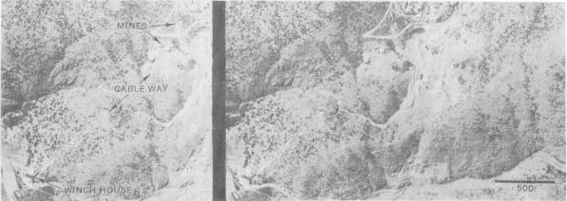

Figure 2-33.

4. Which extraction method is used in Figure 2-34?

A. Shaft mining.

B. Strip mining.

C. Drilling.

D. Open pit mining.

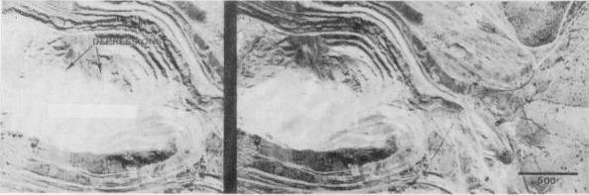

Figure 2-34.

IT0672 38

5. Which material is most likely being extracted in Figure 2-34?

A. Zinc.

B. Uranium.

C. Copper.

D. Salt.

39 IT0672

LESSON TWO

PRACTICE EXERCISE

ANSWER KEY AND FEEDBACK

Item Correct Answer and Feedback

1. B. Gravel appears on black and white photo as dark-grey to light grey (page 19, fig 2-4).

2. A. Sulfur is extracted by drilling (page 20, fig 2-5).

3. B. Shaft mining is used in Figure 2-33 (page 27, fig 2-14).

4. D. Open pit mining is used in Figure 2-34 (pages 23/24/25, para 3b/fig 2-9/fig 2-10).

5. C. Copper is extracted in pit mining similar to the pit shown in Figure 2-34 (pages 20/25, fig 2-5/para 3b/fig 2-10).

IT0672 40

